

 Hash Your First Block – Blockchain Basics and Setup.

**Objective/Aim:**  
  
 To gain an understanding of blockchain fundamentals by setting up the Egeth environment and performing a

demonstration of hashing and mining a block.

**Apparatus/Software Used**

* Personal computer or laptop
* Egeth software
* Internet connection for research and tool access

**Theory/Concept:**

**Understanding Blockchain**

Blockchain is a decentralized and tamper-resistant digital ledger used to store transaction records and track assets in a secure and verifiable way. All participating systems (nodes) maintain a synchronized copy of the data. Once a record is added to the blockchain, altering it is extremely difficult, as changes would require control of more than 51% of thenetwork.

**Brief History**The concept of blockchain emerged in 2008 with the creation of Bitcoin by the pseudonymous Satoshi Nakamoto. Since then, blockchain has evolved to support various applications beyond cryptocurrency, including finance, supply chain, and healthcare.

**Key features of blockchain technology**

1. **Decentralized ledger** – Data is shared across multiple nodes.
2. **Immutability** – Past records cannot be modified without network consensus.
3. **Smart contracts** – Self-executing code that automates agreements.
4. **Public key cryptography** – Ensures secure identity verification and data protection.



**Procedure:**

|  |  |  |  |
| --- | --- | --- | --- |
|  |  | **Marks Obtained** |  |
|  |  |  |  |
|  |  |  |  |
|  |  |  |  |
|  |  |  |  |
|  |  |  |  |
|  |  |  |  |

1. Open the blockchain demonstration tool at: <https://andersbrownworth.com/blockchain/block>
2. Input some sample data into the block’s data field. Observe that any change in the data instantly produces a different hash value.
3. Click **Mine** to adjust the block’s nonce until the hash satisfies the required condition (e.g., starting with a set number of zeros).

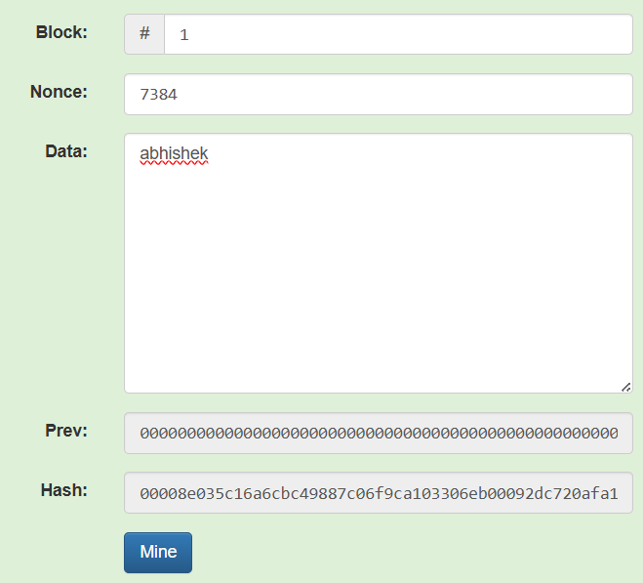 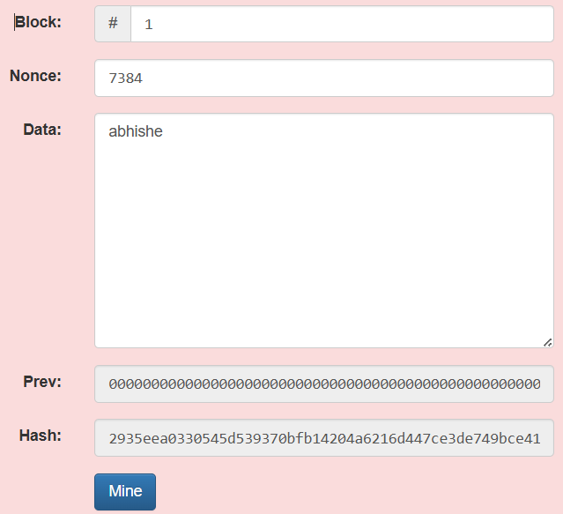

***Becomes invalid when the data is altered* restored to a valid state after successful mining."**

**Observation Table:**

**Prev hash:**

000037e81b88e32fe376d1d7b2f706fb63a7830630bfeb94d44b6906eed41087

**Hash after change:**

2935eea0330545d539370bfb14204a6216d447ce3de749bce4161dbf40cf4

**ASSESSMENT**